Project Development Phase
1. Phase Overview
The development phase focuses on the technical execution of the requirements. It involves setting up a tracking mechanism (Update Set) and configuring the client-side logic (UI Policy) to meet the business objective. This phase ensures that every change is documented and reversible before moving to the production environment.

2. Milestone 1: Version Control Initialization
Before any configuration begins, a container must be created to capture the metadata changes.
- Activity: Create a Local Update Set.
- Steps:
  - Navigate to System Update Sets > Local Update Sets.
  - Click New to create a record.
  - Name: UI_Policy_Mandatory_Priority_v1.0
  - State: Set to In Progress.
  - Submit & Make Current: This ensures all subsequent actions are recorded in this specific set.
- 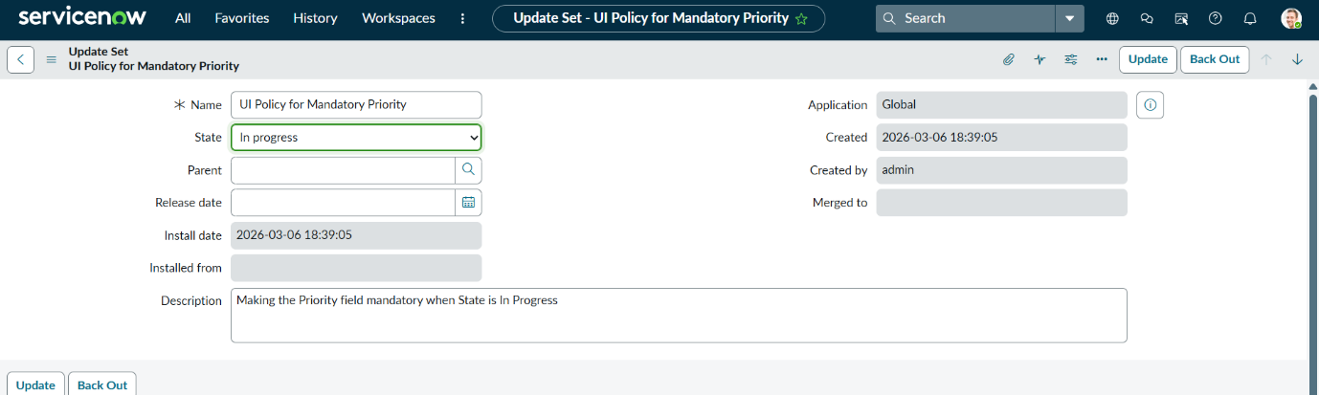

2. Milestone 2: UI Policy Construction
This milestone involves building the core logic that monitors the Incident form.
- Activity: Define the UI Policy logic.
- Steps:
  - Navigate to System UI > UI Policies.
  - Click New and select the Incident [incident] table.
  - Short Description: Enforce Mandatory Priority when In Progress.
  - When to Apply (Conditions): Set to [State] [is] [In Progress].
  - Global: Checked (to ensure it applies to all views).
  - On Load: Checked (to evaluate the state immediately when a record opens).
- 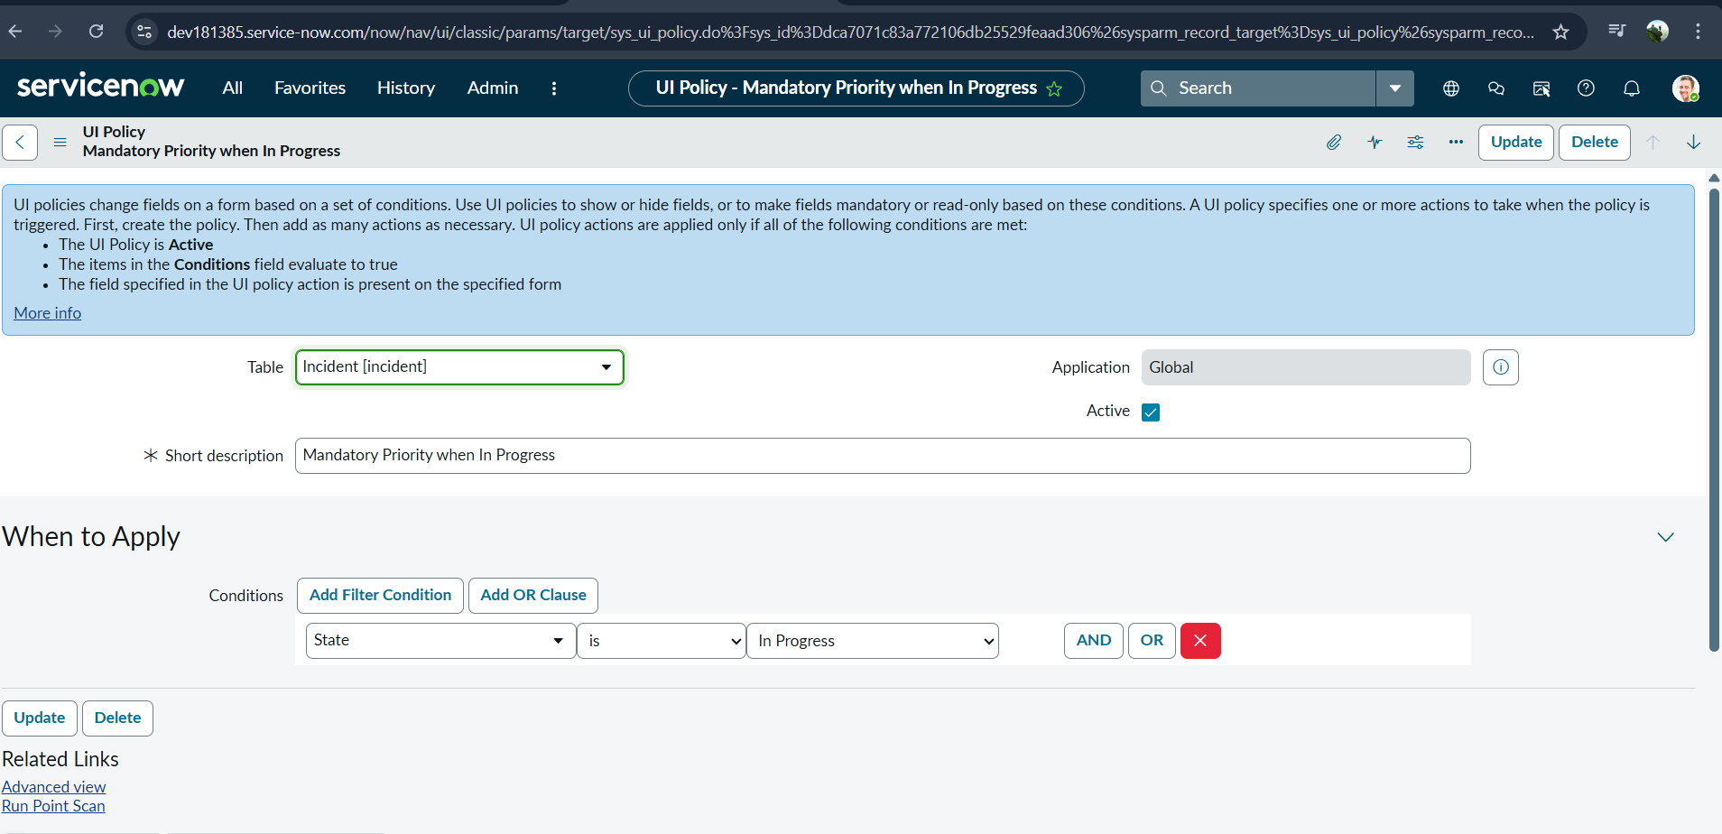

3. Milestone 3: UI Policy Action Definition
Once the "When" is defined, the "What" must be configured.
- Activity: Create a UI Policy Action.
- Steps:
  - Scroll to the UI Policy Actions related list at the bottom of the UI Policy form.
  - Click New.
  - Field Name: Select Priority.
  - Mandatory: Set to True.
  - Visible/Read Only: Leave as Leave alone (unless specific UX requirements dictate otherwise).
  - Submit.
- 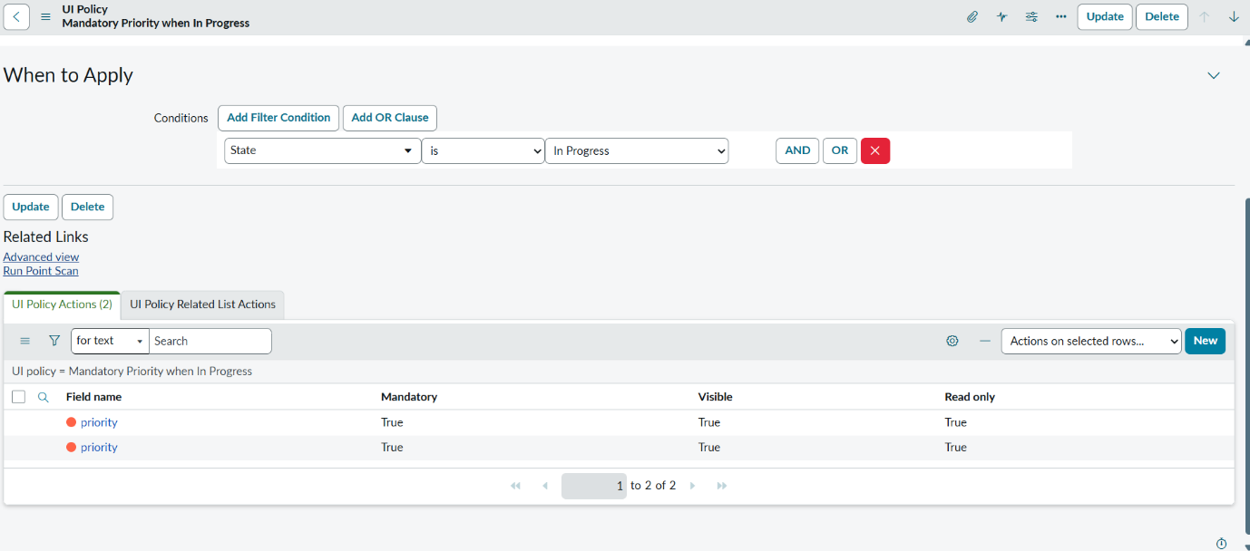

4. Milestone 4: Unit Testing & Validation
Before packaging the change, the developer must verify the logic works as intended.
- Activity: Functional Verification.
- Steps:
  - Open an existing Incident record.
  - Change the State to In Progress.
  - Observation: Verify the red asterisk appears on Priority.
  - Change the State back to New.
  - Observation: Verify the red asterisk disappears.
  - Check the Update Set "Customer Updates" list to ensure both the UI Policy and UI Policy Action records were captured.

5. Milestone 5: Finalization & Packaging
Preparing the development work for migration to the next environment.
- Activity: Closing the Update Set.
- Steps:
  - Return to the Local Update Set record.
  - Change the State from In Progress to Complete.
  - Save the record.
  - Select the Export to XML Related Link to download the migration file.
- 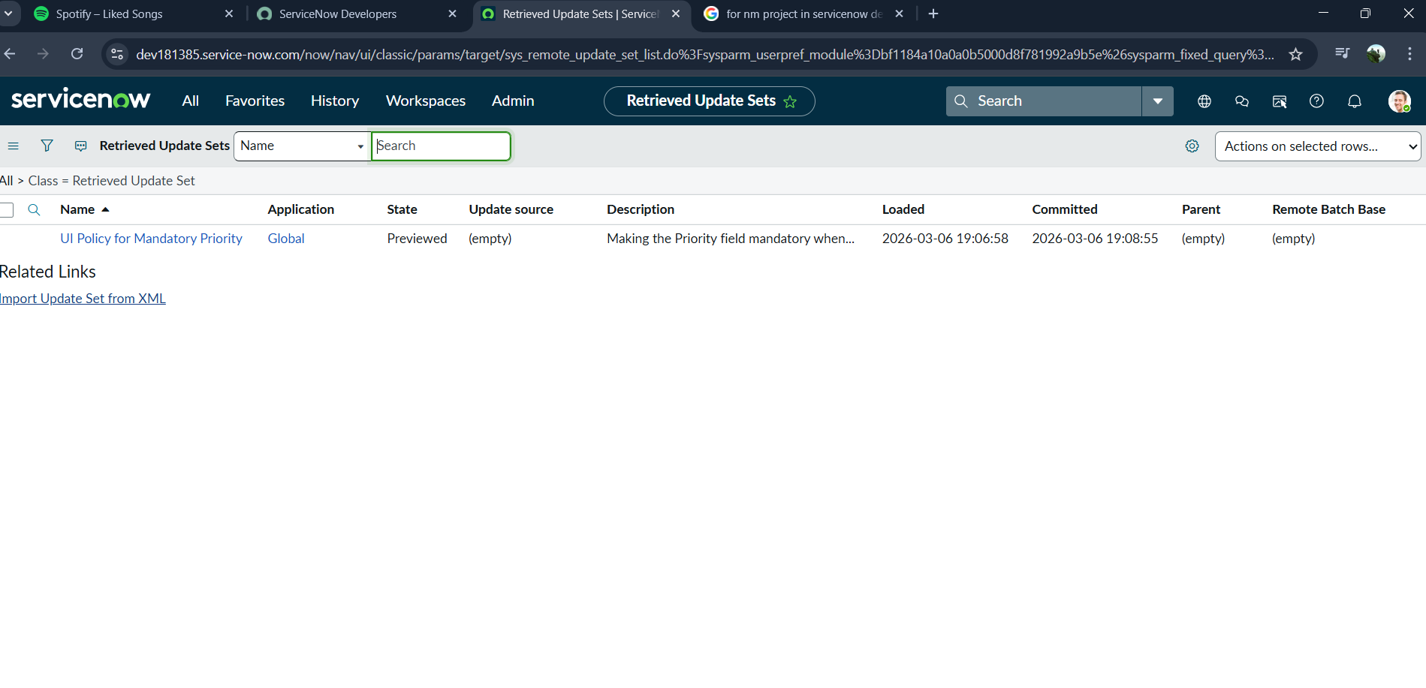

6. Development Outcome
The Development Phase results in a verified XML payload containing the logic required to enforce data integrity. This package is now ready for the Implementation/Migration Phase, ensuring that the exact same logic can be replicated in Test or Production instances with a single click.
